CO2:AT1 ASSESSMENT TOOL
Name:R.MOUNI Course:Generative AI
Reg no: 192472283 Code:CSA6502

Q16. Function-Calling / Tool-Use Prompt
Write a prompt that instructs an LLM on exactly when to call a get_weather(location) function
versus answering directly, including the precise JSON schema the model must output when it decides to
call the function.

Step 1: Open an LLM Website
- ChatGPT – https://chatgpt.com
Step 2: Copy the Prompt
You are an AI assistant with access to a function:
Function Name:
get_weather(location)
Description:
Returns the current weather for the given location.
Rules:
1. If the user asks about the current weather, temperature, rainfall, humidity, or forecast for any location, call the function.
2. If the user asks a general knowledge question or anything unrelated to weather, answer directly without calling the function.
3. When calling the function, output ONLY the following JSON.
{
"function": "get_weather",
"arguments": {
"location": "<location>"
}
}
Do not include explanations before or after the JSON.

Step 3: Test the Prompt

Example 1
Input
What is the weather in Hyderabad?
Expected Output
{
"function": "get_weather",
"arguments": {
"location": "Hyderabad"
}
}

Example 2
Input
Who is the Prime Minister of India?
Expected Output
The Prime Minister of India is Narendra Modi.

Step 4:Python code and Output

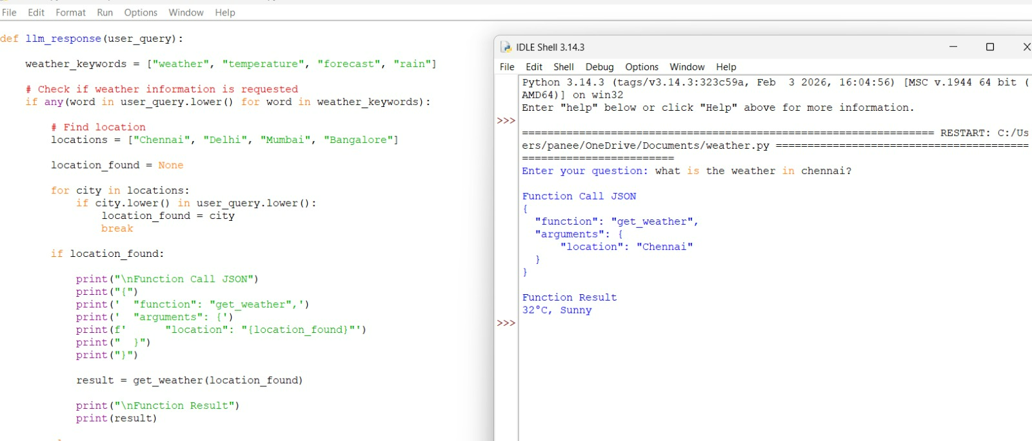

Q17. Comparative / Contrastive Evaluation Prompt
Write a prompt that gives the model two pieces of writing (or two code snippets) and asks it to evaluate both against specific criteria, then declare a winner with justification for each criterion.

Step 1: Open an LLM Website
Use any AI chatbot such as:
- ChatGPT

Step 2: Copy the Prompt Below
You are an expert evaluator.

Compare the following two pieces of writing based on these criteria:
1. Clarity
2. Grammar
3. Organization
4. Accuracy
5. Readability

For each criterion:
- Give Writing A a score out of 10.
- Give Writing B a score out of 10.
- Explain why each score was given.
- State which writing is better for that criterion.

Finally:
- Calculate the total score for each writing.
- Declare the overall winner.
- Explain why it is the better piece of writing.

Writing A:
Artificial Intelligence is changing the world. It helps doctors, students and businesses. AI makes work easier and saves time.

Writing B:
Artificial Intelligence has transformed many industries by improving efficiency and supporting better decision-making. It assists healthcare professionals, enhances education, and automates business operations, making daily tasks more productive.

Step 3: Paste the Prompt
- Open ChatGPT (or any LLM).
- Start a new chat.
- Paste the above prompt.
- Press Enter.

Step 4: Observe the Output
The model will compare both writings.
Example:
Criterion | Writing A | Writing B | Winner
Clarity | 8/10 | 9/10 | B
Grammar | 9/10 | 10/10 | B
Organization | 8/10 | 9/10 | B
Accuracy | 8/10 | 9/10 | B
Readability | 9/10 | 9/10 | Tie

Step 5: Total Score
Example:
Writing A = 42/50

Writing B = 46/50

Step 6: Final Winner
Example:
Winner: Writing B

Reason:
Writing B uses more professional vocabulary,
has better organization,
provides clearer explanations,
and is more suitable for formal writing.

Step 6: Python code and output
